**Web Technologies Laboratory 01**

**Laboratory Continuous Assessment (LCA) [As perRubrics]**

|  |  |  |  |  |  |  |
| --- | --- | --- | --- | --- | --- | --- |
| **Understanding of the Objective**  **(5)** | **Performance**  **(5)** | **Journal**  **Submission and Ethics (Neatness, Handwriting, Timely submission)**  **(5)** | **Orals**  **(5)** | **Total**  **(20)** | **Remarks** | **Instructor’s Sign** |
|  |  |  |  |  |  |  |

**Aim:** Design and develop a web application using HTML and CSS

**Objectives:**

1. To understand HTML tags
2. To learn the styling of web pages using CSS

**Theory:**

1. Basic structure of HTML program
2. CSS Box Model

**FAQ:**

1. What is a responsive Website?
2. What is the difference between HTML and HTML5?
3. What is a marquee?
4. What are the advantages of using Cascading Style Sheets?

**Output: Screenshots of the output to be attached.**

**HTML:** HTML is the standard markup language for creating Web pages. It stands for Hyper Text Markup Language. It describes the structure of Web pages using markup. HTML elements are the building blocks of HTML pages. HTML elements are represented by tags. Hypertext is text that contains [hyperlinks](http://www.linfo.org/hyperlink.html). A hyperlink is an automated cross-reference to another location on the same document or to another document which, when selected by a user, causes the [computer](http://www.linfo.org/computer.html) to display the linked location or document within a very short period of time.

A [markup language](http://www.linfo.org/markup_language.html) is a set of tags that can be embedded in digital text to provide additional [information](http://www.linfo.org/information.html) about it, including its [content](http://www.linfo.org/content.html), structure and appearance. This information facilitates automated operations on the text, including formatting it for display, searching it and even modifying it.

HTML consists of a set of predefined tags that can be embedded in text by web site designers in order to indicate the details of how web pages are rendered (i.e., converted into a final, easily usable, form) by [web browsers](http://www.linfo.org/browser.html). These details include paragraphing, margins, fonts (including style and size), columns, colors (background and text), links, the location of images, text flow around images, tables and user input form elements (such as spaces for adding text and submit buttons).

**HTML tags:** This is a list of tags used in the [HTML](https://www.w3.org/History/19921103-hypertext/hypertext/WWW/MarkUp/MarkUp.html" \l "4) language. Each tag starts with a tag opener (a less than sign) and ends with a tag closer (a greater than sign). Many tags have corresponding closing tags which identical except for a slash after the tag opener. Some tags take parameters, called attributes. The attributes are given after the tag, separated by spaces. Certain attributes have an effect simply by their presence, others are followed by an equals sign and a value.

The basic HTML layout is as follows:

<html>

<head>

<title> *…document title…* </title>

</head>

<body>

*…your page content…*

</body>

</html>

The page components are described as follows:

<!DOCTYPE html PUBLIC "-//W3C//DTD XHTML 1.0 Transitional//EN" "http://www.w3.org/TR/xhtml1/DTD/xhtml1-transitional.dtd">

First line of code

Declaration of version of HTML

<html>…</html>

Container for the document

<head>…</head>

<title> Title of page </title>

<body>…</body>

Content of page

Examples of HTML tags are as follows:

## Heading Tags: It defines the heading size in the HTML sheet.

## <h1>, <h2>, <h3>, <h4>, <h5>, and <h6>

<html>

<head>

<title>Heading Example</title>

</head>

<body>

<h1>This is heading 1</h1>

<h2>This is heading 2</h2>

<h3>This is heading 3</h3>

<h4>This is heading 4</h4>

<h5>This is heading 5</h5>

<h6>This is heading 6</h6>

</body>

</html>

## Paragraph Tag: Inserts a line space before and after a paragraph

<!DOCTYPE html>

<html>

<head>

<title>Paragraph Example</title>

</head>

<body>

<p>Here is a first paragraph of text.</p>

<p>Here is a second paragraph of text.</p>

<p>Here is a third paragraph of text.</p>

</body>

</html>

## Line Break Tag:

<!DOCTYPE html>

<html>

<head>

<title>Line Break Example</title>

</head>

<body>

<p>Hello<br />

You delivered your assignment ontime.<br />

Thanks<br />

Mahnaz</p>

</body>

</html>

**Image Tag:** In HTML, images are defined with the <img> tag.The <img> tag is empty, it contains attributes only, and does not have a closing tag.The src attribute specifies the URL (web address) of the image:

<img src="*url*">

The alt attribute provides an alternate text for an image, if the user for some reason cannot view it (because of slow connection, an error in the src attribute, or if the user uses a screen reader). The value of the alt attribute should describe the image:

<img src="img_chania.jpg" alt="Flowers in Chania">

**Link Tag:** HTML links are hyperlinks. In HTML, links are defined with the <a> tag:

<a href="*url*">*link text*</a>

The href attribute specifies the destination address of the link. The link text is the visible part.

<a href="https://www.w3schools.com/html/">Visit our HTML tutorial</a>

**HTML5 tags:** HTML5 offers new semantic elements to define different parts of a web page:

* **<article>**
* **<aside>**
* **<details>**
* **<figcaption>**
* **<figure>**
* **<footer>**
* **<header>**
* **<main>**
* **<mark>**
* **<nav>**
* **<section>**
* **<summary>**
* **<time>**

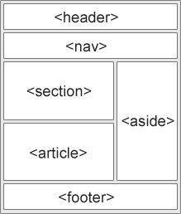

## Difference between HTML & HTML5: The major differences in HTML and HTML5 are as follows:

## HTML5 has over its unnumbered predecessor is that it has high-level audio and video support which was not a part of the version specifications in previous HTMLs.

## HTML doesn’t allow JavaScript to run within the web browser (it instead runs in the browser interface thread) whereas HTML5 provides full support for JavaScript to run in the background.

## HTML5 supports new kinds of form controls, for example: dates and times, email, number, range, tel, url, search etc.

## HTML5 uses web SQL databases, application cache for temporary storing data, meanwhile, in HTML, only browser cache could be utilized for this purpose.

**CSS: Cascading Style Sheets** (**CSS**): CSS is the acronym for "Cascading Style Sheet". HTML is used to control the structure of web document. CSS is used to control the style of a web document in a simple and easy way.

**CSS** stands for **C**ascading **S**tyle **S**heets.

CSS describes **how HTML elements are to be displayed on screen, paper, or in other media**.

CSS **saves a lot of work**. It can control the layout of multiple web pages all at once.

CSS can be added to HTML elements in 3 ways:

* **Inline** - by using the style attribute in HTML elements
* **Internal** - by using a <style> element in the <head> section
* **External** - by using an external CSS file

## Inline CSS

An inline CSS is used to apply a unique style to a single HTML element.

An inline CSS uses the style attribute of an HTML element.

This example sets the text color of the <h1> element to blue:

### **Example**

<!DOCTYPE html>

<html>

<body>

<h1 style="color:blue;">This is a Blue Heading</h1>

</body>

</html>

Output:

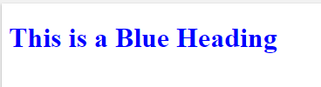

## Internal CSS

An internal CSS is used to define a style for a single HTML page.

An internal CSS is defined in the <head> section of an HTML page, within a <style> element:

### **Example**

<!DOCTYPE html>  
<html>  
<head>  
<style>  
body {background-color: powderblue;}  
h1   {color: blue;}  
p    {color: red;}  
</style>  
</head>  
<body>  
  
<h1>This is a heading</h1>  
<p>This is a paragraph.</p>  
  
</body>  
</html>

Output:

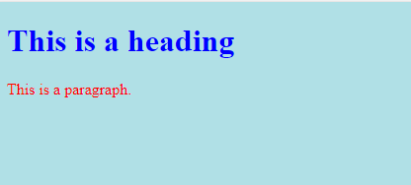

## External CSS

An external style sheet is used to define the style for many HTML pages.

**With an external style sheet, you can change the look of an entire web site, by changing one file!**

To use an external style sheet, add a link to it in the <head> section of the HTML page:

### **Example**

<!DOCTYPE html>  
<html>  
<head>  
  <link rel="stylesheet" href="styles.css">  
</head>  
<body>  
  
<h1>This is a heading</h1>  
<p>This is a paragraph.</p>  
  
</body>  
</html>

An external style sheet can be written in any text editor. The file must not contain any HTML code, and must be saved with a .css extension.

Here is how the "styles.css" looks:

body {  
  background-color: powderblue;  
}  
h1 {  
  color: blue;  
}  
p {  
  color: red;  
}

Output:



## CSS Box Model

All HTML elements can be considered as boxes. In CSS, the term "box model" is used when talking about design and layout.

The CSS box model is essentially a box that wraps around every HTML element. It consists of: margins, borders, padding, and the actual content. The image below illustrates the box model:

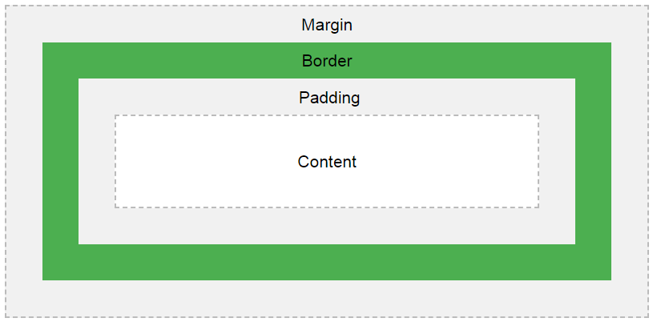

Explanation of the different parts:

* **Content** - The content of the box, where text and images appear
* **Padding** - Clears an area around the content. The padding is transparent
* **Border** - A border that goes around the padding and content
* **Margin** - Clears an area outside the border. The margin is transparent

The box model allows us to add a border around elements, and to define space between elements.

### **Example**

Demonstration of the box model:

div {  
  width: 300px;  
  border: 15px solid green;  
  padding: 50px;  
  margin: 20px;  
}

Output:

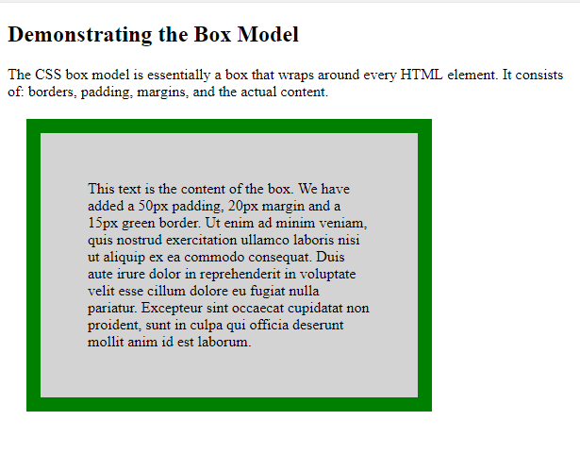

**CSS Selectors**

CSS selectors are used to "find" (or select) the HTML elements you want to style.

## The CSS element Selector

The element selector selects HTML elements based on the element name.

### **Example**

Here, all <p> elements on the page will be center-aligned, with a red text color:

p {  
  text-align: center;  
  color: red;  
}

<!DOCTYPE html>

<html>

<head>

<style>

p {

text-align: center;

color: red;

}

</style>

</head>

<body>

<p>Every paragraph will be affected by the style.</p>

<p id="para1">Me too!</p>

<p>And me!</p>

</body>

</html>

Output:

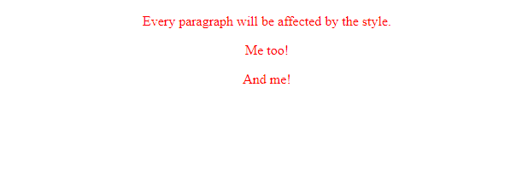

## CSS id Selector

The id selector uses the id attribute of an HTML element to select a specific element.

The id of an element is unique within a page, so the id selector is used to select one unique element!

To select an element with a specific id, write a hash (#) character, followed by the id of the element.

### **Example**

The CSS rule below will be applied to the HTML element with id="para1":

#para1 {  
  text-align: center;  
  color: red;  
}

<!DOCTYPE html>

<html>

<head>

<style>

#para1 {

text-align: center;

color: red;

}

</style>

</head>

<body>

<p id="para1">Hello World!</p>

<p>This paragraph is not affected by the style.</p>

</body>

</html>

Output:

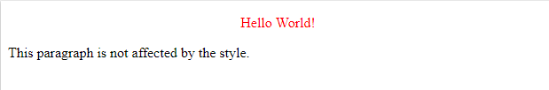

## CSS Class Selector

The class selector selects HTML elements with a specific class attribute.

To select elements with a specific class, write a period (.) character, followed by the class name.

### **Example**

In this example all HTML elements with class="center" will be red and center-aligned:

.center {  
  text-align: center;  
  color: red;  
}

<!DOCTYPE html>

<html>

<head>

<style>

.center {

text-align: center;

color: red;

}

</style>

</head>

<body>

<h1 class="center">Red and center-aligned heading</h1>

<p class="center">Red and center-aligned paragraph.</p>

</body>

</html>

Output:

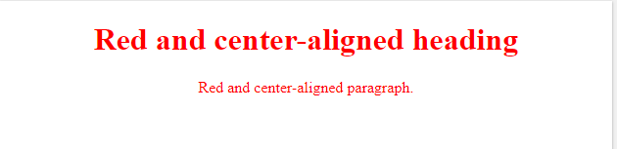

## CSS Universal Selector

The universal selector (*) selects all HTML elements on the page.

### **Example**

The CSS rule below will affect every HTML element on the page:

* {  
  text-align: center;  
  color: blue;  
}

<!DOCTYPE html>

<html>

<head>

<style>

* {

text-align: center;

color: blue;

}

</style>

</head>

<body>

<h1>Hello world!</h1>

<p>Every element on the page will be affected by the style.</p>

<p id="para1">Me too!</p>

<p>And me!</p>

</body>

</html>

Output:

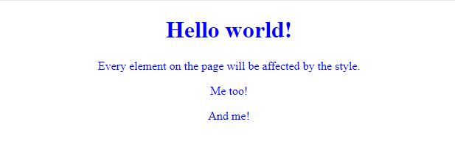

## CSS Grouping Selector

The grouping selector selects all the HTML elements with the same style definitions.

Look at the following CSS code (the h1, h2, and p elements have the same style definitions):

h1 {  
  text-align: center;  
  color: red;  
}  
  
h2 {  
  text-align: center;  
  color: red;  
}  
  
p {  
  text-align: center;  
  color: red;  
}

It will be better to group the selectors, to minimize the code.

To group selectors, separate each selector with a comma.

### **Example**

In this example we have grouped the selectors from the code above:

h1, h2, p {  
  text-align: center;  
  color: red;  
}

<!DOCTYPE html>

<html>

<head>

<style>

h1, h2, p {

text-align: center;

color: red;

}

</style>

</head>

<body>

<h1>Hello World!</h1>

<h2>Smaller heading!</h2>

<p>This is a paragraph.</p>

</body>

</html>

Output:



**Design / execution steps:**

* Open Notepad.
* Write the HTML code
* Save the HTML page with the extension .html or .htm
* Write the CSS code in a separate file. Save using the extension .css
* Link both files using the link tag in html file
* View the HTML page in the browser

**Input:** HTML file and CSS File

**Output:** Webpage is displayed on browser

**Conclusion:** Hence, we have designed static web pages using HTML and CSS.